AMOD 5610H Project Progress Report

# This is worth 5% of your grade and should be a brief update on what work has been done to this point. We don’t expect your project to have a completed prototype of the whole thing yet, but you should have some functional parts. Team Member(s) and Project

|  |
| --- |
| **List your team member(s) and a one sentence description of your project (this is just to help us remember which is which, not any sort of thing we need to evaluate).**  Predict whether or not a person with certain features is supposed to be away from work at certain points in time.(Absenteeism).  **Team Members**   1. **Sahil Nagpal (0670042)** 2. **Pramina Patil (0663967)** |

# Current Progress

Outline what has been achieved, in an ideal world this will be related to your plan from the previous assignment, and you should be able to list which phases are completed and what parts work.   
Realistically, you are likely to have individual pieces of code that solve pieces of problems rather than full phases completed.

|  |
| --- |
| 1. **Loading the data** **(DONE)**– The gathering and the loading part of the data is done successfully. The data captured is in the comma separated format and is loaded for pre-processing. 2. **Identify the Independent Variable (DONE)**- It is more complex than it first appears to decide which variable is the most significant. We have finalize which variables we are going to use as the independent variable which eventually helps us to yield the logical as well as the predictable results. 3. **Determine the Algorithm to develop Model(DONE)** – This is one of the most essential segment of producing the outcome. In this phase we have come with the algorithm which fits well to our use case as well as to our corresponding data. 4. **Data Pre-processing (DONE) –** The data pre- processing work is also completed, the data is now capable of predicting the results which helps us to understand the pattern.  * **Remove or Treat Missing Value.** * **Remove Outliers.** * **Standardize the data.** * **Normalize and the scale the data.**  1. **Split Data into Train and Test** **(IN PROGRESS)** - Divide our train and test data and build the model on the set of train data. |

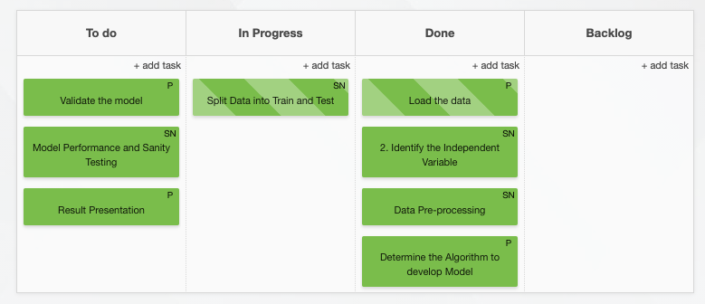

# Work Remaining

In this section you should outline what work is remaining, and any significant deviations from the plan submitted in the previous assignment

|  |
| --- |
| 1. **Validate the model (TO DO)**– In this point of solving phase , we will save the model and deploy it on the cloud for its effective usage. In order to save the model we need to pickle the model. We will also create the executable file for the same. 2. **Model Performance and Sanity Testing** **(TO DO)**– We will test the model on the new data set with same feature and will also perform the sanity testing of the result generated from the new dataset. 3. **Result Presentation** **(TO DO)**– It is known to be a best practice to store the data and the predictive results under a certain database. |

# Individual Contributions

Who has done what in your group to this point?

|  |
| --- |
| At this point of time :   1. **Loading and Sharing the data** – This part of the project is completed by the Pramina Patil. 2. **Identifying the Independent Variable** - This part of the project is completed by the Sahil Nagpal. 3. **Data Pre-processing** - This part of the project is completed by the Sahil Nagpal. 4. **Determining the Algorithm to develop model** - This part of the project is completed by the Pramina Patil. |